Multiple-choice section

|  |  |  |  |  |  |  |  |  |  |  |
| --- | --- | --- | --- | --- | --- | --- | --- | --- | --- | --- |
| Question | 1 | 2 | 3 | 4 | 5 | 6 | 7 | 8 | 9 | 10 |
| Answer | A | C | D | C | B | D | C | B | B | A |

Question 1 [4.1]

A

|  |  |  |  |  |
| --- | --- | --- | --- | --- |
| Ones | . | Tenths | Hundredths | Thousandths |
| 1 | . |  |  |  |
| 0 | . | 3 | 2 |  |

0.32 = 

Question 2 [4.1]

C

Each interval is 0.01. Marks are 2.01, 2.02, etc.

Question 3 [4.2]

D

2.278

Look to the next digit (8) after the second decimal place. Round up to 2.78.

Question 4 [4.3]

C



Question 5 [4.5]

B

1.7 × 4 = 6.8

Question 6 [4.7]

D

|  |  |
| --- | --- |
| Method 1:  Multiply by 100% | Method 2:  Change to a fraction out of 100 |

Question 7 [4.7]

C

0.15 written as a percentage = 0.15 × 100%.  
This moves the decimal point two places to the right. So, 0.15 = 15%.

Question 8 [4.8]

B



$=\frac{10}{100}×\$40=\frac{1}{1}×\$4=\$4$

Question 9 [4.8]

B



Question 10 [4.9]

A

There are 2 pigs to 3 ducks so ratio is 2 : 3.

Multiple-choice total marks: 10

Short answer section

Question 11 3 marks [4.3, 4.9]

(a) To write a fraction as a decimal, you divide the *numerator* by the denominator.

(b) A *terminating* decimal is one that does not keep repeating.

(c) To find an equivalent ratio, you *multiply* or divide both parts by the same number.

Question 12 3 marks [4.1]

(a)

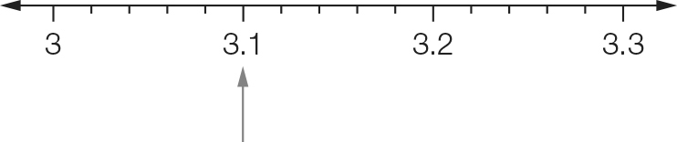

(b)

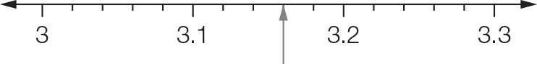

Each interval is 0.02. You need two intervals after 3.1.

(c)

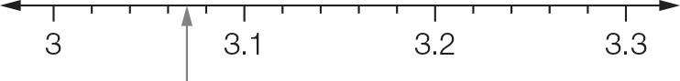

Each interval is 0.20. 3.03 is halfway between 3.02 and 3.04.

Question 13 2 marks [4.1]

(a) $4+\frac{3}{10}+\frac{6}{100} = 4.36$ (b) $\frac{3}{100}+\frac{1}{1000}+\frac{5}{10000}=0.0315$

Question 14 2 marks [4.1]

(a) 4.023 $4+\frac{3}{10}+\frac{6}{100} = 4.36$, 4.23, 4.32

(b) 0.00754, 0.07054, 0.0754

Question 15 1 mark [4.1]

|  |  |  |  |  |
| --- | --- | --- | --- | --- |
| Ones | . | Tenths | Hundredths | Thousandths |
| 1 | . |  |  |  |
| 4 | . | 3 | 0 | 2 |

4.302

Question 16 3 marks [4.2]

(a) 18.642 ≈ 18.6  
The digit after the 6 is 4. As this is less than 5 the 6 is not rounded up.

(b) 7362 ≈ 0.74  
The digit after the 3 is 6. As this is more than 5 the 3 is rounded up.

(c) 2.095 ≈ 2.1  
The digit after the 3 is 6. As this is more than 5 the 3 is rounded up.

Question 17 3 marks [4.2]

(a) 23.777 ≈ 23.78  
The digit after the 7 is 7. This is rounded up.

(b) 1.3387 ≈ 1.339  
The digit after the 8 is 9. This is rounded up.

(c) 23.749 ≈ 23.7  
The digit after the 7 is 4. This is not rounded up.

Question 18 2 marks [4.4]

|  |  |
| --- | --- |
| (a) 3.40  +3.58  6.98 | (b) 5.00  0.30  + 4.65  9.95 |

Question 19 2 marks [4.4]

|  |  |
| --- | --- |
| (a) 5 . 7 8 5 –0 . 2 3 4  5 . 5 5 1 | (b) |

Question 20 3 marks [4.5]

(a) 34.65 × 100 = 3465

(b) 0.6723 × 1000 = 672.3

(c) 8.3 × 4 = 33.2

Question 21 2 marks [4.5]

(a) 1.8 × 200  
= 1.8 × 2 × 100

= 3.6 × 100  
= 360

(b) 0.3 × 0.6  
(3 × 6 = 18)  
0.3 × 0.6 = 0.18

(2 decimal places in the question, so there are 2 decimal places in the answer)

Question 22 3 marks [4.6]

(a) 27.48 ÷ 10 = 2.748 (move 1 decimal place left)

(b) 8.12 ÷ 100 =0.0812 (move 2 decimal places left)

(c) 22.4 ÷ 4 = 5.6  


Question 23 6 marks [4.7]

|  |  |  |
| --- | --- | --- |
| Fraction (simplest form) | Decimal | Percentage |
|  | 0.1 | 10% |
|  | 0.5 | 50% |
|  | 0.25 | 25% |
|  | 0.2 | 20% |
|  | 0.75 | 75% |
|  | 0.6 | 60% |
|  | 0.333… | 33.33...% |

Question 24 2 marks [4.8]

|  |  |
| --- | --- |
| (a) | (b) |

Question 25 2 marks [4.8]

14 marks out of 25:



Question 26 4 marks [4.9]

(a) 4 : 7 (× 4)  
= 16 : 28 (÷ 2)  
= 8 : 14

(b) 2 : 5 : 3 (× 3)  
= 6 : 15: 9

Short answer total: 43

Extended answer section

Question 27 7 marks [4.1, 4.4, 4.6]

(a)–(b)

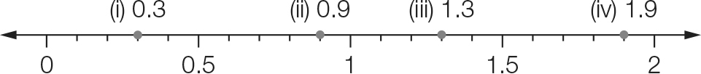

(c) A = 0.58

(d) Using the number line:

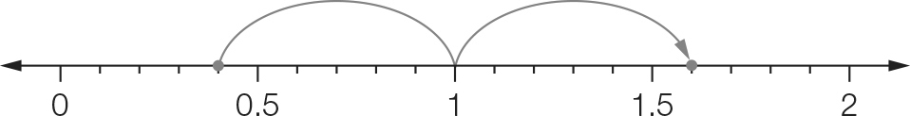   
The point halfway between 0.4 and 1.6 is 1.0.

Using arithmetic:

(0.4 + 1.6) ÷ 2 = 2 ÷ 2 = 1

Question 28 6 marks [4.4, 4.8, 4.9]

(a) 16.03 – 0.11= 15.92 seconds

(b) 16.21 – 15.92 = 0.29 seconds

(c) (i) 

One serve is 2000 kJ.

(ii) The breakfast serving size is 3 × 2000 = 6000 kJ.

(d) dinner : lunch  
= 2 : 2  
= 1 : 1

(e)



Extended answer total: 13

TOTAL test marks: 66